COLEMAN UNIVERSITY Computer Information Systems Name: Michael Fetick
COM 280 Object Oriented Analysis and Design Student No. 84270
NOTE: The Syllabus, the Course Schedule and the Student Manual were provided only on a hard-copy media. I have not transferred my written notes on this topic to text yet.
Collaboration Diagram
My Notes
Exercises – Collaboration Diagram
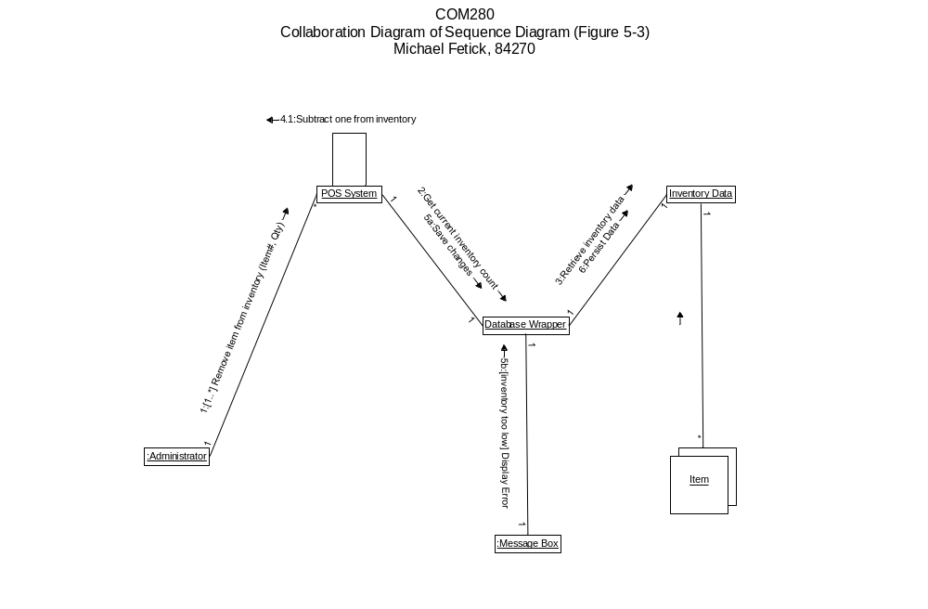
Project 4 – Collaboration Diagram

Project 4 (5 points)
Develop collaboration diagrams for Figures 8-33, 8-34, 8-35 in R:\COM280\Carol Koon Assignments\June 2013 Projects\Project 4 Collaboration Diagram\Project 4 Collaboration Diagram.pdf.
Project due date: Tuesday, July 2, 2013 11:30 p.m. PDT.
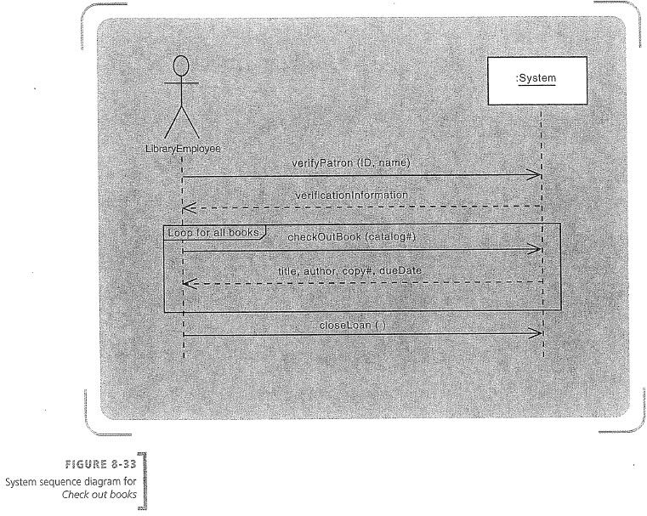
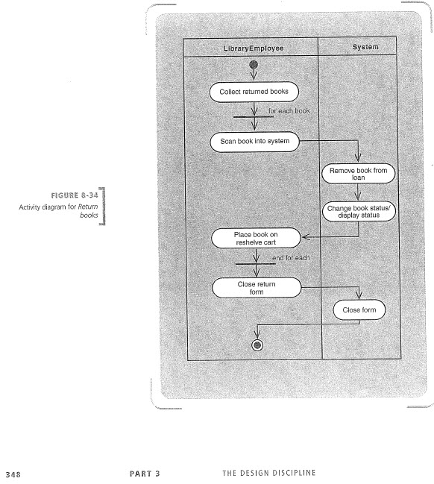
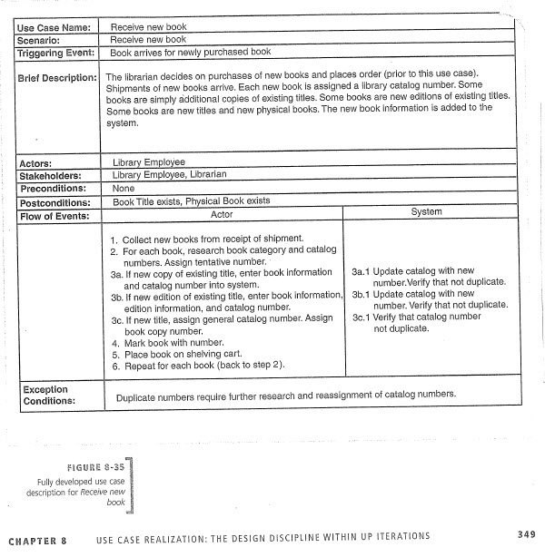
COLEMAN UNIVERSITY Computer Information Systems Name: Michael Fetick
COM 280 Object Oriented Analysis and Design Student No. 84270
